// check the documentation in the code

Operators

Incrementation : increasing exiting value by 1

Post incrementation a++

pre incrementation ++a

Eg: Incrementation_1

Eg:Increment_Eg_2

// if in print statement post increment is applied , first printed and then incremented

// even though if we use “-“ in increment the result will be positively incremented line 5 but since it is written in print statement first “a” is printed then incremented and in line 8 “a” is printed which consists of incremented value .

Eg: Increment_Eg_3

Eg: Increment_Eg_4

// Here post increment is applied i.e in if condition 5 is loaded in i and then condition check since 5<6 ,it enters into the loop

And after that in print statement again post increment i.e first 6 is printed and then incremented

Eg: Increment_Eg_5

// check documentation in code

Eg: Increment_Eg_6

program flow

1. During the execution of line 3 ,since bracket is present the compiler first compiles the code in the bracket
2. Now evaluation is done in bracket i.e ++x (pre increment is done and x will be incremented to 5)
3. Now outside the bracket, since the inner bracket code is evaluated and x becomes 5 , we cant increment literal , which throws compilation error

// first check Eg:Increment_Eg_5 and go with this code

Eg:Increment_Eg_7

//check documentation in the code

Eg: Increment_Eg_8

// go through the code

Eg: Increment_Eg9

int a =7;

Result = a++ == 7 && ++a == 9 || a++ == 9;

In post increment first a value is stored as 7 and then incremented , condition (7==7) is checked with 7 only but not incremented one.

short circuit operator checks only for true , since first condition is true it will not evaluate other.

Increment_Eg10

Since post increment first variable is fetched and then incremented . the condition is checked with the original value not with the incremented one .

Decrementation : decreasing value by 1

// decrementation also similar to incrementation . check incrementation example , it will be enough.

% in arithmetic operator stores remainder .

Eg: Modulo_Operator

Logical operator :

&& Short circuit AND operator -> all the conditions should be true only then result is true else false

Second operand evaluation will happen only if first operand evaluation is true

Eg: Short_Circuit_AND_Operator

Eg: Short_Circuit_AND_Eg_2

|| Short circuit OR operator -> if one condition is true result will be true , it will not check for other condition. If both conditions are false result will be false.

Second operand evaluation will happen only if first operand evaluation is false

Eg: Short_Circuit_OR_Operator

Eg: Short_Circuit_OR_Operator_Eg2

// go through the program

Eg: Short_Circuit_OR_Operator_Eg3

// first condition is true , so other condition is not evaluated .

Bitwise

& Logical AND operator (or) Bitwise And -> truth table is same as Short Circuit AND Operator

Eg: Bitwise_AND

| Logical OR operator (or) Bitwise Inclusive OR -> truth table is same as Short Circuit OR Operator

Eg: Bitwise_Inclusive_OR

^ Bitwise Exclusive OR ->

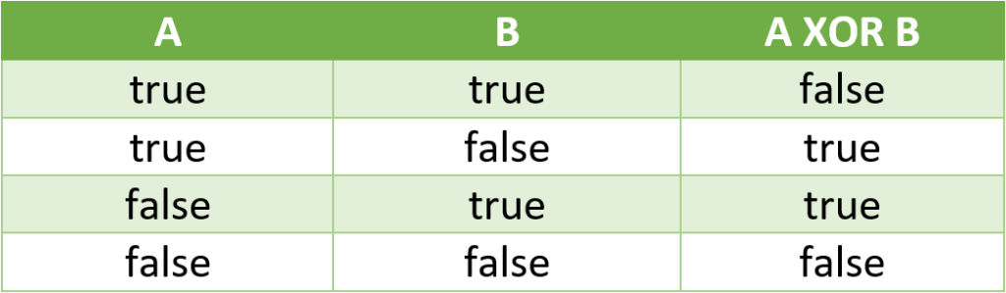

Eg: Bitwise_Exclusive_OR

// go through the code

! -> boolean compliment

!true -> false

!false -> true

! -> bitwise compliment

-(n+1)

Eg : ~ 25 -> -(25+1) -> -26

Eg: ~ -36 -> -(-36+1) -> -(-35) -> 35

Relational operators:

It will return boolean either true (or) false , internally it makes use of or operator.

Assignment operator :

Single assignment

a = 10

chained assignment :

int a,b,c,d ;

chained assigned is not possible in method parameters

a = b = c = d =10; assignment is done from right to left , i.e first 10 to d and it is passed upto a .

Eg: Chained_Assignment_Eg1

// check documentation in code

compound assignment :

a +=10 => a = a+10

Eg: Assignment_Operator

Eg: Assignment_Operator_Eg2

// Here j is being reassigned (compound assignment)

Unary operators :

If you are using any operators and it involves only one operand it is called unary operator

Eg: a = 10 here a is operand .

a+=20

a++

Eg: Assignment_Operator_Eg3

First R.H.S side is evaluated and then it is assigned to assignment operator example : x = 2

x *= 2+3*5

x = x*25

x = 2*25 => 50

number literal increment is not possible , leads to compile time error.

Example : 1+ ++x

Space should be given after first addition otherwise complier treats increment is for literal (1+++x) which leads to compile time error .

increment decrement , assignment operators are unary

Binary operators :

if you are using any operators and it involves more than one operand it is called binary operators

Eg: a+b

a-b

a>b

a==b

Switch cases

In switch case if certain case is matching it is executed and all the cases below the matching cases will be executed

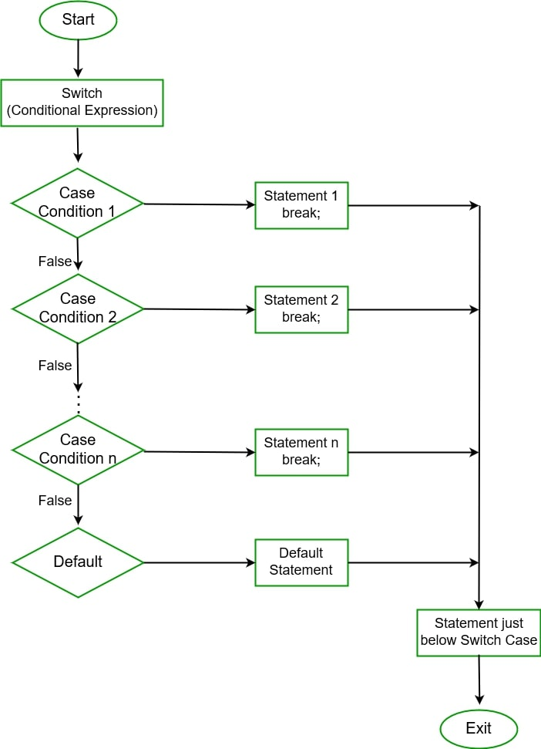

To stop that use break

If all the cases are wrong you can use default and it is optional

Eg: Switch_Case_Eg1

Eg: Switch_Case_Eg2

//statement is not a part of case label so compile time error

Eg: Switch_Case_Eg3

//label in switch should be “compile time constants” , the value should be known to compiler.

Line 9 y is not compile time constant

Eg: Switch_Case_Eg4

// go through the code

Eg: Switch_Case_Eg5

// go through the program

Eg: Switch _Case_Eg6

// label in switch should be “compile time constants” meaning the value should be known to compiler other wise compile time error. ( case (label) : )

Label value should be in the range of the args type I ( byte x)

Eg: Switch_Case_Eg7

//go through the code

Eg: Switch_Case_Eg8

1) label in switch statement should be “compile time constants” , meaning the value should be know to compiler otherwise C.E

2) Label value should be within the range of the switch argument otherwise C.E

3) duplicate case values are not allowed.

In the line 11 label value is a ‘literal’ not a operand which satisfies the first condition .

char value we can store in int

what compiler do is

int x = ‘a’ the corresponding value of the char is 97 , where 97 is already a label value , so it is compile time error.

Eg: Switch_Case_Eg9

// Here the case label which is matching is executed and the remaining labels below the matching label will also be executed , since there is no break statement

Eg: Switch_Case_Eg10

// default can be placed anywhere in the switch ,but it will be executed only when no case labels are matching.

If you place “ ->” in default cannot other use cases , so always use “ : ”

When tried with x =1 , case labels , 1 & 2 are executed since there is no break in case 1 and 2 . All the cases will be executed after the matching case labels ,as there is no break statement

When tried with x =2 , case label 2 is executed since there is no case labels beyond only it is executed.

When tried with x =3 , so there is no matching case labels defuault will be executed.

Eg: Switch_Case_Eg11

//go through the program

## Eg: Switch_Case_Eg12

//control goes to case 3 executes and since there is no break statement default also executes.

Eg: Switch_Eg13

// Note :

Switch(arg) can only be

byte -> Byte

short -> Short

int -> Int

char -> Character

String

enum

Eg: Switch_Eg14

Case sensitive mango is different from Mango

Eg: Switch_Eg15

default can be placed anywhere inside switch . the control flow will be like this

1. All the cases will be evaluated first , if no cases are matching then default will be executed

Here default is written first , since no cases are matching , default statement is printed , and after default as there is no break statement , all the remaining cases also gets printed ,irrespective of their the case condition.

Note : after the matching case ( correct condition case ) all the below remaining cases will also gets executed if there is no break ,

Eg: Switch_Eg16

After matching case if there is no break and default is below the matching case , default will also gets executed .

Eg: Switch_Eg17

If any below case has break statement after the matching case , the execution stops / terminates at that break statement .

Eg: Switch_Eg18

// go through the code

Eg: Switch_Eg19

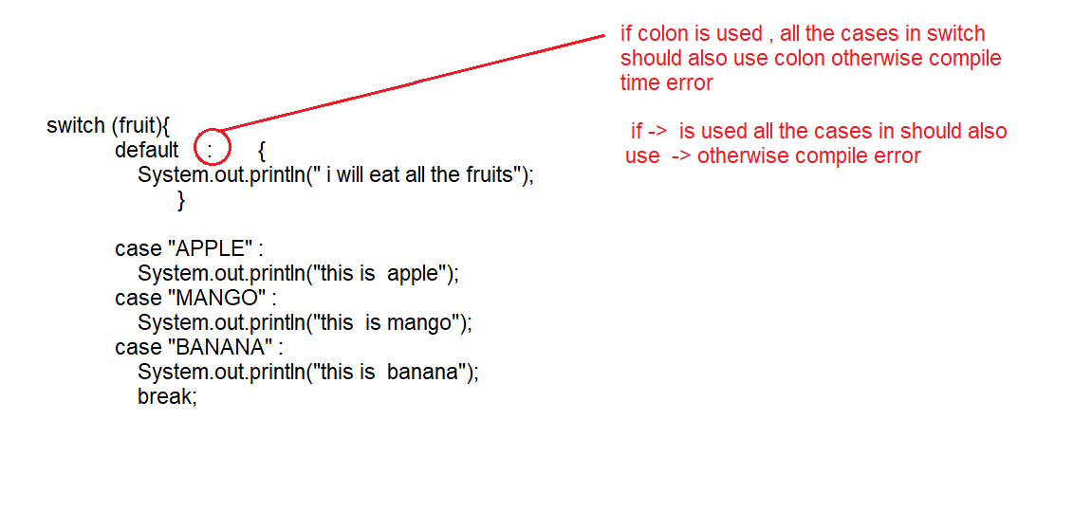

Eg: Switch_Eg20

// check Eg13

## Java Ternary Operator

## Java Ternary operator is used as one line replacement for if-then-else statement and used a lot in Java programming.

## It is the only conditional operator which takes three operands.

Eg : Teranary_Operator

Eg: Nested_Ternary_Operator

// In the above program first type checking is done . all of them are of int type , so there is no compilation error.

Eg: Ternary_Operator_Eg2

// if literals are involved in ternary operator compiler will directly do the computation before jvm

Eg: Ternary_Operator_Eg3

Here literals are not involved in the program , so compiler will do just type checking , result is computed in the run time

Line 4 consists of variables “a” and “b” which is of type int , and result is also an int , but it cant be assigned to byte so it leads to compilation error.

Eg: Ternary_Operator_Eg4

// go through the code

// if the expression result is of same data type , as of variable

There is no compilation error .

If the expression result is of different data type and we are storing that in the different data type it is a compile time error

Eg: Ternary_Operator_Eg5

// go through the program

If Conditional statement:

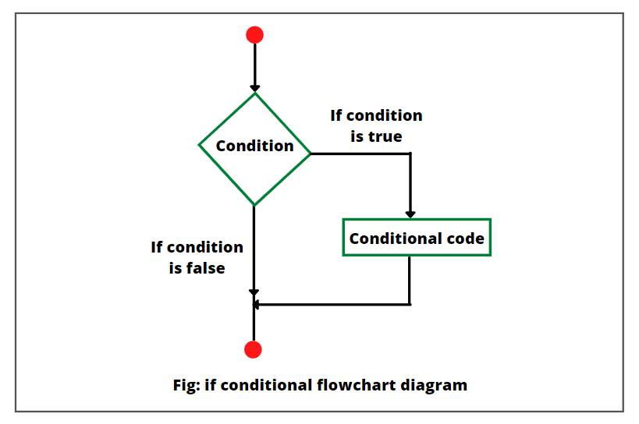

Eg: If_Else_1

Eg: If_Else_If_Ladder_2

Eg: If_Else_3

// If works only on boolean , does not work for other datatypes. but int is given

Eg: If_Else_4

// If works only on boolean , does not work for other datatypes. Here are assigning = , but actually we should use == (used to check whether both are equal are not) it returns boolean .

Eg: If_Else_5

//go through the code it will be enough.

Eg: If_Else_6

// here we assigned boolean to variable b , and in if statement

Instead of checking we again reassigned boolean .

If statement also expects the boolean , so no compilation error program flow continues without compilation error

Eg: If_Else_7

// here we are checking whether boolean false is equal to true are not.

Since false is not equal to true it moves to else block.

Eg: If_Else_8

//If there is one statement which needs to be part of if then { } braces can be omitted , but that statement should not be a declarative statement

Eg: If_Else_9

// semicolon is also a valid java statement

Eg: If_Else_10

// go through the code

Eg: If_Else_11

// we can use declarative statement only if we use flower brackets , since we use flower brackets here it is valid

Eg: If_Else_12

// go through the code for documentation

Eg: If_13

//go through the code

Eg: If_14

// break can be used only in switch, loop and labeled block

If we try to use in other places it leads to compile time error

Eg: If_15

//continue can be used only in the loops.

We can use them in labeled blocks but only if there are part of the loops. you cannot use in the switch .

Note : break statement moves the control out of the current working loop

continue skips the current iteration and further iterations work normally

Eg: If_Else_16

// concept of unreachability is only for loops (for, while, do-while) compiler will ignore unreachability for if else syntax.

Compiler will just give a warning , will not throw compile time error .

Eg: Label_break

{  
} // block

Labelled block in java can be given as labelname:{

}

If we doesn’t use labeled block and used a normal block ,When break statement is used , compiler doesn’t know which one to terminate , it leads to compile time error ,so we have used label block and mentioned label name after block , so that compiler can identify that it should terminate the block.

Eg: If_Else_Eg17

else block should always come immediately after the if block . no other declarations or statements , should be in between them .

Eg: If_Else_Eg18

// go through the code

Note: unreachable wont be checked by compiler for if and else logic

Eg: If_Else_Eg19

// go through the code

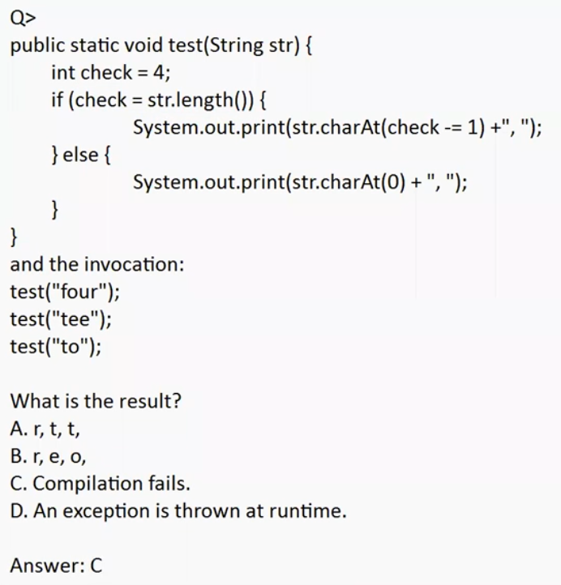

In the if the condition should be boolean.

Eg: Operators

// go through the program

Eg: Operators_Eg2

// go through the code

Eg: Operators_Eg3

// go through the code

Eg: Operators_Eg4

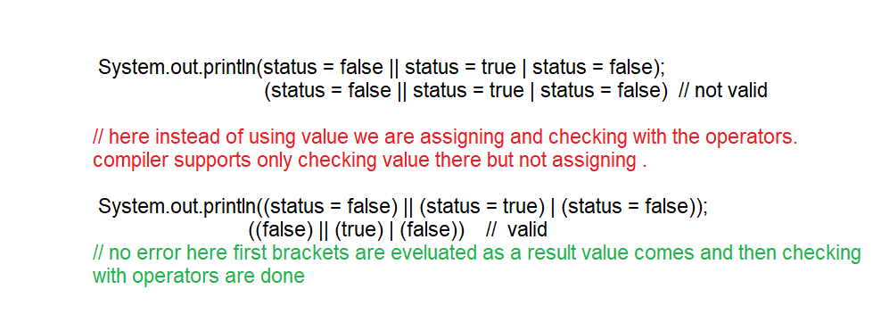

Eg: Operator_Eg5

// go through the program

Eg: Operator_Eg6

// go through the program